# Premises licence analysis – West Sussex

Density of alcohol outlets

March 2023

Author: Dr Rich Tyler

## Introduction

This short report shows analyses of publicly available data on licenced premises in West Sussex. It forms part of a wider Health Equity Audit (HEA) series of work on Alcohol in West Sussex.

More details of other aspects can be found…

## Premises licences in England and Wales

A premises licence is required for any commercial premises that are used for the sale or supply of alcohol. A premises licence is also required to provide hot food and drinks between 11pm and 5am, and/or the premises hosts the following forms of regulated entertainment, either for profit or for charity:

* theatrical performance
* film exhibition
* indoor sporting event
* boxing or wrestling (indoor or outdoor)
* live music
* recorded music
* dance

UK Government; accessed 06/03/2023 - <https://www.gov.uk/premises-licence>

Private clubs are an exception to the requirement for a premises licence, as they may instead require a Club Premises Certificate.

Lower Tier Local Authority and Unitary Authorities are the licencing authorities in England and Wales.

## Current analysis

Where the licensing authority has made the register readily available and easily accessible we have extracted premises name and postcode and any other relevant information and geolocated the postcode using open-source postcode look ups.

This has so far been possible with Adur, Arun, and Worthing licence registers.

Data for Adur is as at 5th June 2019 and Worthing data is correct as at 26th February 2020. Arun district council have a public register for licences, food businesses and other registers which is continuously added to. An extract of the current premises data was downloaded from the register on the 6th March 2023. It is likely that new licences have been granted since these published dates and some of the licences will have ceased. However, this will give us a good approximation on the availability of alcohol outlets and explore area characteristics such as deprivation.

Some registers have better information than others in terms of the level of detail available (e.g. whether the premises is licenced as an ON or OFF sales premises). In this preliminary analyses we simply plot the approximate location of any premises with a licence under the Licensing Act 2003 and this will include pubs, bars, restaurants, shops, supermarkets, community spaces with kitchens, and other premises where providing alcohol is a very small part of the business operation. We have excluded schools where possible from the premises list.

Future analysis could include more focused filtering and make use of information such as opening hours, type of premises and whether the premises licence includes ON and/or OFF sales.

## Overall summary

The first table below shows the total number of premises licences reported to Home Office as at 31st March 2022 by each licencing authority in West Sussex[1].

**Table of expected premises numbers as at 31st March 2022**

| **Licensing authority** | **Total Premises licences** |
| --- | --- |
| Adur | 149 |
| Arun | 502 |
| Chichester | 605 |
| Crawley | 285 |
| Horsham | 509 |
| Mid Sussex | 474 |
| Worthing | 410 |
| **Total** | 2,934 |

## Obtained data

For this analysis, we extracted data for Adur, Arun, and Worthing covering a total of 933 premises for which we had enough detail to geolocate. We excluded schools where possible although some late night takeaways which do not sell alcohol may also be included in the data as well as premises such as community centres and halls which can be hired and only on occasion be used for consuming alcohol.

The figure below shows the premises included in the analyses.

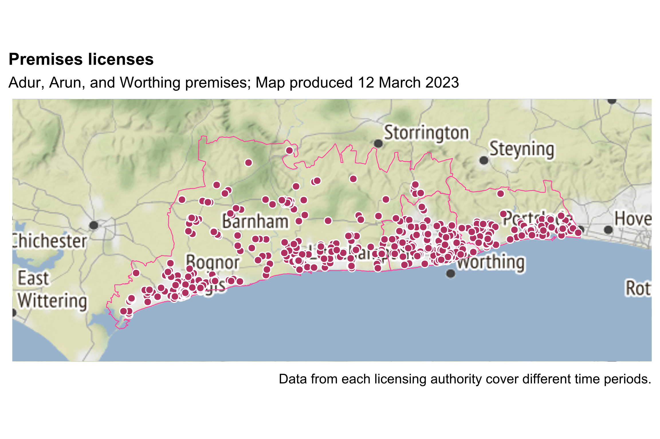TODO - Can we classify into on premises licences (1) pubs, bars, nightclubs, (2) restaurants, (3) other on trade premises, (4) supermarkets, (5) convenience stores, (6) other off trade premises

Only data for Adur and Worthing contain enough detail to identify whether the premises licence covers ON premises alcohol consumption or premises selling alcohol only for consumption OFF premises. The next figure shows the premises in Adur and Worthing which specified conditions for OFF and ON premises alcohol supply. This meant that another 36 premises in Adur and Worthing were excluded because the licence conditions did not mention OFF or ON premises alcohol sale/supply (likely because the venues had premises licences for other purposes such as late night food takeaway sales).

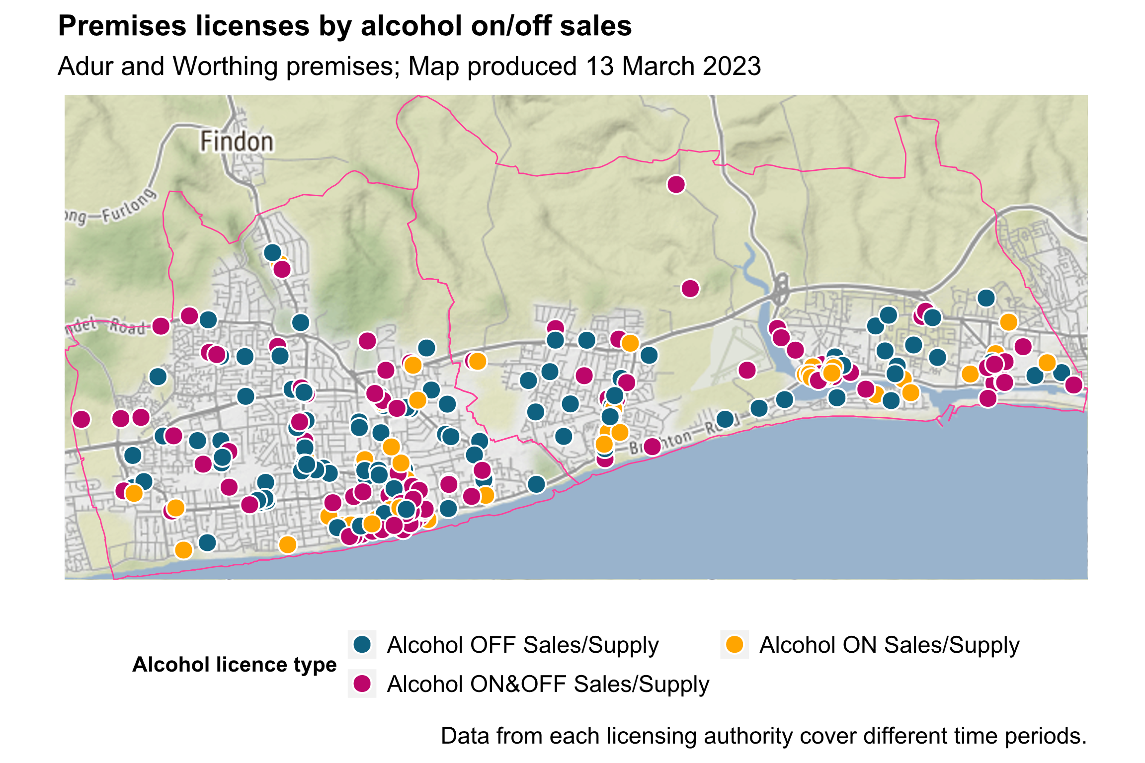

As such, the remainder of the analysis focusses on the 456 premises for which we have a high confidence that the premises explicitly supplies/sells alcohol for consumption either on or off premises.

Overall, Worthing had the highest density of premises per square kilometre (table 2)

| **LTLA** | **Outlets** | **Square kilometres** | **Outlets per km2** |
| --- | --- | --- | --- |
| Adur | 148 | 42.0655 | 3.518323 |
| Worthing | 308 | 32.5209 | 9.470833 |

At LSOA level, the variation in number and density of outlets is even starker.

Top ten neighbourhoods with the highest number of outlets per km2

**TODO Show deprivation map – LSOA (small multiples – national, west sussex, LTLA based ranks**

**TODO Show deciles number of outlets**

So far we have looked at mostly containment measures of alcohol outlet density which look at the number of outlets ‘contained’ within particular geographical boundaries.

These are simplistic measures (e.g. number of premises per square km or number in each neighbourhood) which implicitly assume that the population of an area is evenly distributed and that residents are unaffected by outlets outside of their immediate geographical boundaries (Richardson et al, 2015).

Instead, Richardson et al (2015) proposed a method of calculating the density of outlets around a single point for each area representing the population weighted centroid to capture the alcohol retail environment exposed to the majority of a population.

Previous studies have OFF sale outlines concentrated in areas of socioeconomic disadvantage

## Linking outlet patterns and alcohol harm outcomes

Maheswaran et al. (2018) reported that the overall relationship between alcohol outlet density and hospital admission rates was comparable in deprived and affluent areas[2].

1. [Alcohol and late night refreshment licensing England and Wales, year ending 31 March 2022 - GOV.UK (www.gov.uk)](https://www.gov.uk/government/statistics/alcohol-and-late-night-refreshment-licensing-england-and-wales-31-march-2022/alcohol-and-late-night-refreshment-licensing-england-and-wales-year-ending-31-march-2022)
2. [Alcohol outlet density and alcohol related hospital admissions in England: a national small‐area level ecological study - Maheswaran - 2018 - Addiction - Wiley Online Library](https://onlinelibrary.wiley.com/doi/10.1111/add.14285)